Experiment No.: 2

Title: Preparing Software Project Management Plan (SPMP)

Batch: A3 Roll No.: 16010421119 Experiment No.: 2

Aim: To Prepare Software Project Management Plan (SPMP)
___________________________________________________________________________
Resources needed: Internet Explorer, GanttProject, LaTex Editor ___________________________________________________________________________

Theory

The software project management plan specifies:
- the objectives of the project,
- the project dependencies and constraints,
- the project deliverables, and
- the project timetable.
This document describes how you intend to develop your software; how you expect to approach the development process; the times and deliverables involved; problems foreseen and constraints imposed. The plan accompanies the project life span and is usually subject to a number of revisions.
SPMP Template:
1 INTRODUCTION
1.1 Project Overview
Provide a description of the purpose of the software, who the project is being executed for and the expected delivery date.
1.2 Project Deliverables
List the project deliverables/”work products” (documents, source code, library files, executable code, databases), and the delivery date for each (the date that each is to be complete).

2 PROJECT ORGANIZATION
2.1 Software Process Model
Identify and describe the software process model you will use in terms of the following:
? ? the flow of information and work products,
? ? reviews to be conducted,
? ? major milestones to be achieved,
? ? versions to be established,
? ? project deliverables to be completed,
To describe the process model, a combination of graphical and textual notations may be used.

2.2 Roles and Responsibilities
In the case of a group project, identify the various roles, the project team members, and their assignments. Take care to identify how information will be communicated between the different roles – for example: how will the design be passed to the coder.
Use diagrams to show the project structure, and the lines of communication within the project.
2.3 Tools and Techniques
Specify the development methodologies, notations, programming languages, techniques, and tools you plan to use at each stage of the project.
For example: you might use OO for the analysis phase, using the UML notation, and the Rational Rose Tool. In order to track changes to the analysis, you might use version control, and the CS-RCS tool.
This section should include details of the coding standards to be used.

3 PROJECT MANAGEMENT PLAN
3.1 Tasks
Identify the tasks involved in executing the project. Some sample tasks are:
? ? requirements analysis/clarify the requirements
? ? requirements analysis/develop an exploratory prototype and get feedback from the user
? ? requirements analysis/write the SRS
? ? system design/develop the design using Rational Rose
? ? system design/write the SDD
? ? development/develop version 1
? ? development/develop version 2
? ? system test/test version 1
? ? system test/test version 2
Tasks should be specified in enough detail to allow estimation of the time required, and to allow tracking of project status. As a very rough guide, tasks should take about one week.
3.1.n Task-n
Provide a name for the task, and a unique identifier of the form SPMP.
3.1.n.1 Description
A brief description of the task.
3.1.n.2 Deliverables and Milestones
A list of the deliverables of the task (documentation, code, other), and the milestones associated with these. For example, milestone 1 of the project might be the delivery of the final revisions of the SRS, STD, and SPMP; milestone 2 might be delivery of the STD, milestone 3 might be completion of version 1 (development & test), etc.
3.1.n.3 Resources Needed
Identify the resources needed to execute the task (equipment, access to papers/books, etc.)
3.1.n.4 Dependencies and Constraints
Identify the dependencies that must be met before the task can be started or completed, and any constraints placed on the task.
For example: detailed design can’t start until the requirements are complete, or there is a constraint that Java be used as the programming language.
3.1.n.5 Risks and Contingencies
Identify the risks associated with getting this task completed on time, and the contingency plans to cope with this risk. You can never identify all the risks; and some events would just stop the project completely. Limit this section to reasonable risks.
For example: what is the probability of you being unable to get the programming language you plan on using running on your computer? What would you do to recover?

3.2 Assignments
For group projects, identify the assignment of team members to tasks.

3.3 Timetable
Provide a timetable showing the estimated start and completion dates for each task. This is best illustrated using a Gantt chart diagram.
This timetable should be updated throughout the project to reflect changes in: the tasks, the execution time for tasks, the completion dates, etc.

__________________________________________________________________________
Procedure:
- Prepare Gantt chart using Gantt Project.
- Prepare SPMP document for chosen problem definition in LaTeX.
_______________________________________________________________________
Results: SPMP Document in given format

Step 1: Adding tasks in Gantt Project
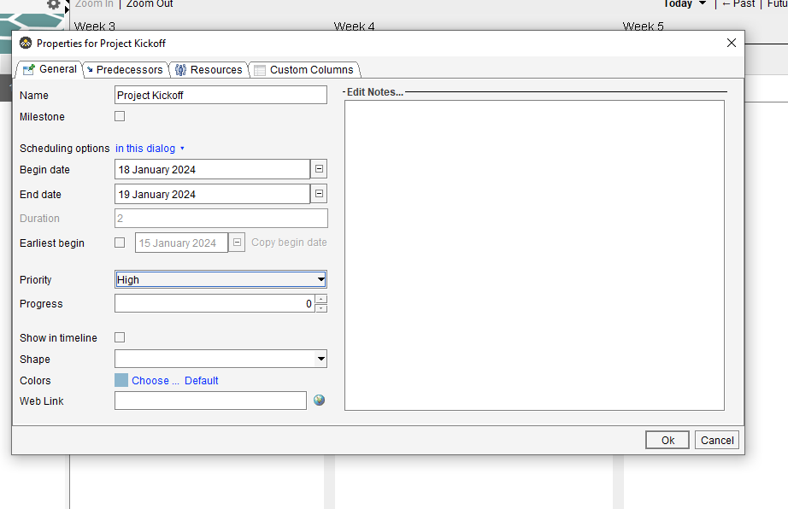
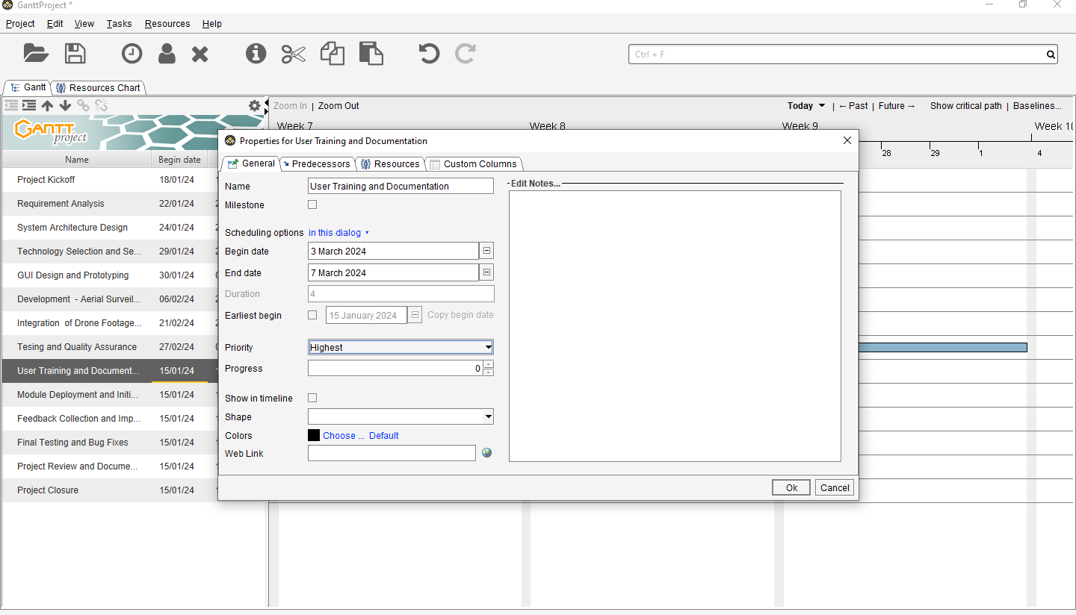
Step 2: Defining Tasks
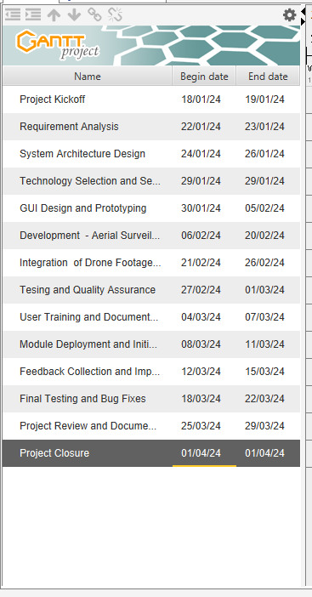

Final Gantt Chart
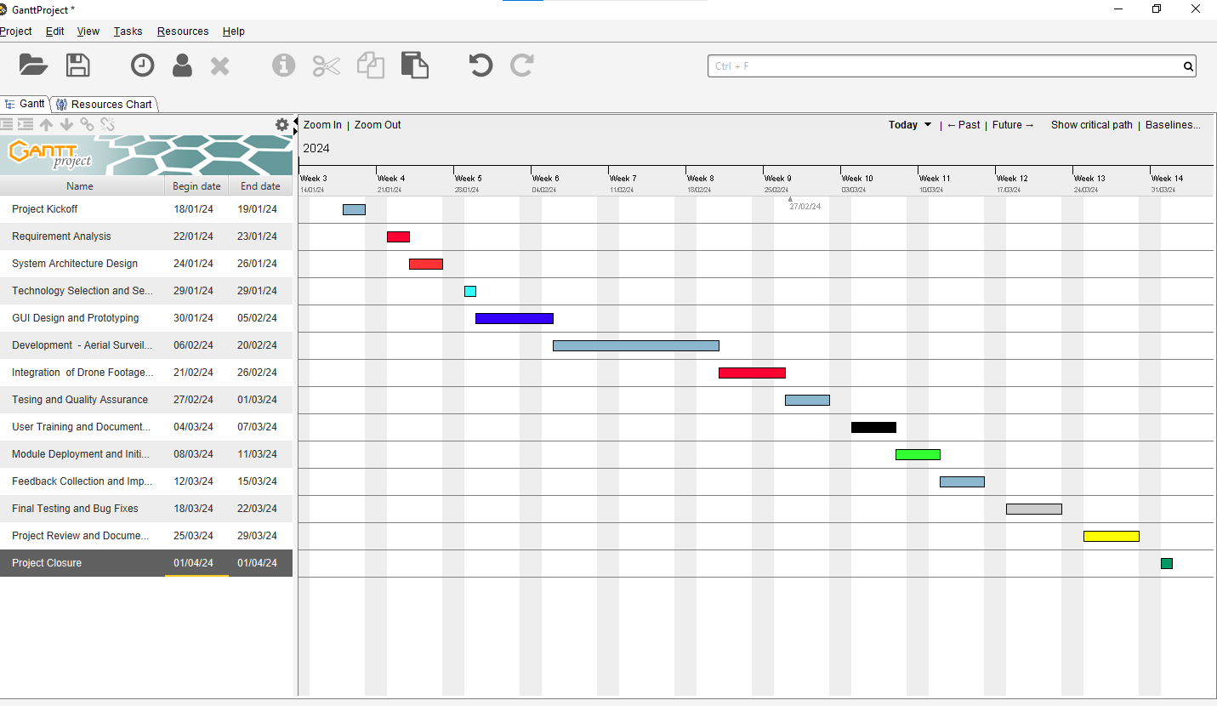
LaTeX Code for SPMP Document:
\documentclass{article}

\usepackage[utf8]{inputenc}
\usepackage{geometry}
\usepackage{graphicx}
\usepackage{float}
\usepackage{hyperref}

\geometry{
a4paper,
total={170mm,257mm},
left=20mm,
top=20mm,
}

\title{Software Project Management Plan (SPMP)\\Remote Wildlife Monitoring and Conservation Application}
\author{Aarya Tiwari and Dhairya Satra}
\date{\today}

\begin{document}

\maketitle

\tableofcontents
\newpage

\section{Introduction}

\subsection{Project Overview}

The Remote Wildlife Monitoring and Conservation Application aims to address the increasing threats to wildlife habitats by leveraging technology for habitat monitoring, wildlife tracking, and environmental assessment. This SPMP outlines the project management approach for its development.

\subsection{Objectives}

\begin{itemize}
\item Develop a comprehensive Remote Wildlife Monitoring and Conservation Application.
\item Implement Aerial Surveillance and Habitat Monitoring module.
\item Enhance wildlife monitoring, conservation management, research, education, and stakeholder engagement.
\end{itemize}

\section{Project Scope}

The project includes:

\begin{itemize}
\item Aerial surveillance using drones.
\item Installation of camera traps and sensor networks.
\item Data collection, analysis, visualization, and reporting functionalities.
\item Collaboration and stakeholder engagement initiatives.
\item Education and outreach programs.
\end{itemize}

\section{Choice of Process Model}

For the development, the Iterative and Incremental Development Model will be employed, allowing continuous improvement, flexibility, and adaptability.

\section{Roles and Responsibilities}

\begin{itemize}
\item \textbf{Project Manager:} Overall coordination, planning, execution, monitoring, and control.
\item \textbf{Technical Lead:} Architectural design, technology selection, system integration, and quality assurance.
\item \textbf{Data Scientist:} Data collection, preprocessing, analysis, modeling, visualization, and decision-making.
\item \textbf{GIS Specialist:} Spatial data management, mapping, and environmental planning.
\item \textbf{Drone Operators:} Aerial surveillance, data capture, and equipment maintenance.
\item \textbf{Field Researchers:} Camera trap deployment, wildlife monitoring, and data collection.
\item \textbf{Community Engagement Officer:} Stakeholder collaboration, capacity building, and communication.
\item \textbf{UI/UX Designer:} User interface design, usability testing, and visual aesthetics.
\item \textbf{Quality Assurance Team:} Testing, validation, bug tracking, and quality control.
\end{itemize}

\section{Module: Aerial Surveillance and Habitat Monitoring}

\subsection{Functionality}

\begin{itemize}
\item Display live drone footage, images, and sensor readings.
\item Enable users to navigate, zoom, pan, and interact with aerial maps.
\item Provide access to historical data, trends, patterns, alerts, and notifications.
\item Allow users to configure settings, filters, parameters, and preferences.
\end{itemize}

\subsection{Objectives}

\begin{itemize}
\item Monitor wildlife habitats.
\item Assess environmental conditions.
\item Track endangered species.
\item Identify conservation priorities.
\end{itemize}

\subsection{Benefits}

Enhanced user engagement, data accessibility, visualization capabilities, and decision-making support for conservation initiatives.

\section{Conclusion}

This SPMP provides a framework for the successful development of the Remote Wildlife Monitoring and Conservation Application. It outlines the project's objectives, scope, choice of process model, roles and responsibilities, and specific details about the Aerial Surveillance and Habitat Monitoring module.

\end{document}

_______________________________________________________________________
Questions:

- Can a project be undertaken without a plan? What are the possible consequences?
Ans: Undertaking a project without a plan can lead to various challenges and consequences. A project plan serves as a roadmap, providing guidance on how to execute, monitor, and control the project.
Not planning and controlling a project can lead to several negative consequences. Three examples include:
- Scope Creep: Without proper planning and control, a project's scope can expand beyond its original boundaries. This can lead to increased costs, delays, and a loss of focus on the project's original objectives.
- Budget Overruns: Inadequate planning and control can result in unexpected expenses, causing the project to exceed its budget. This can strain resources and lead to financial issues for the organization.
- Missed Deadlines: Without effective planning and control, a project may struggle to meet its deadlines. This can impact stakeholder confidence, damage the organization's reputation, and potentially result in missed opportunities.

________________________________________________________________________
Outcomes:
CO2: Describe software planning and management
___________________________________________________________________________
Conclusion:

We can conclude that we have learnt about LaTex and making a Gantt Chart for a project.

Grade: AA / AB / BB / BC / CC / CD /DD

Signature of faculty in-charge with date

___________________________________________________________________________
References:

Books:
- Roger S. Pressman, Software Engineering: A practitioners Approach, 7th Edition, McGraw Hill, 2010.
- Ian Somerville, Software Engineering, 9th edition, Addison Wesley, 2011.
- John M. Nicholas, “Project Management for Business and Technology”, 2nd edition, Pearson Education

